Transglobe Consultancy Website UI Clone

Front-End Development Project Report
Prepared By:
Nidhi Mangtani
Amrita Vishwa Vidyapeetham
Computer Science Engineering (CSE) – C
1. Project Overview
The project is a premium, fully responsive Landing Page for TransGlobe Edu, an overseas education consultancy firm. It serves as a modern digital storefront designed to convert visiting prospects into consulting leads.
The application is structured as a single-file template (HTML5, CSS3, and Vanilla JavaScript) engineered to yield ultra-fast loading times and cross-browser stability. It targets students looking for international higher education opportunities by balancing professional authority with an inviting user interface.
2. Key Features
- High-Performance Architecture: Entirely free of heavy external frameworks (like Bootstrap or Tailwind CSS). It achieves an ultra-lightweight codebase using custom CSS Variables and native layouts while pulling crisp typography and icons from Google Fonts and FontAwesome.
- Intelligent Responsive Design: Implements a fluid breakdown grid system via CSS Media Queries. The webpage perfectly adapts its structures dynamically between Large Displays, Tablets, and Smartphones without overlapping or structural distortion.
- Dynamic Content Metrics (Animated Counters): Features an advanced Intersection Observer script that detects when a user scrolls to the numbers panel. It seamlessly triggers individual numerical data items to rapidly animate upward until hitting target values (e.g., 15,000+ Students Placed).
- Robust Mobile Navigation System: Integrates a hidden off-canvas structural drawer menu. Clicking the mobile burger button creates a side-swipe interface overlay to ensure effortless touch-screen mapping.
- Interactive Hover and Motion Feedback: Enhanced with custom microscopic UI animations, including smooth micro-lifts on service cards, soft-scaling click feedback on country flags, and a smooth-scrolling floating anchor system (#) that gracefully navigates the viewport to sections without sudden page jumps.

CODE –
<!DOCTYPE html>
<html lang="en">
<head>
<meta charset="UTF-8">
<meta name="viewport" content="width=device-width, initial-scale=1.0">
<title>TransGlobe Edu - Study Abroad Consultants</title>
<link rel="stylesheet" href="https://cdnjs.cloudflare.com/ajax/libs/font-awesome/6.4.0/css/all.min.css">
<style>
* { margin: 0; padding: 0; box-sizing: border-box; }
:root {
--primary-blue: #1a365d; --accent-orange: #f97316; --light-blue: #3b82f6;
--dark-text: #1f2937; --light-gray: #f3f4f6; --white: #ffffff;
}
body { font-family: 'Segoe UI', Tahoma, Geneva, Verdana, sans-serif; line-height: 1.6; color: var(--dark-text); }
.container { max-width: 1200px; margin: 0 auto; padding: 0 20px; }

/* Top Bar & Header */
.top-bar { background: var(--primary-blue); color: var(--white); padding: 8px 0; font-size: 14px; }
.top-bar .container, .header .container, .mobile-nav-header { display: flex; justify-content: space-between; align-items: center; flex-wrap: wrap; }
.top-bar-left { display: flex; gap: 20px; }
.top-bar-left a, .top-bar-right a { color: var(--white); text-decoration: none; display: flex; align-items: center; gap: 5px; transition: color 0.3s; }
.top-bar-left a:hover, .top-bar-right a:hover, .nav a:hover { color: var(--accent-orange); }
.top-bar-right { display: flex; gap: 15px; font-size: 16px; }

.header { background: var(--white); box-shadow: 0 2px 10px rgba(0,0,0,0.1); position: sticky; top: 0; z-index: 1000; }
.header .container { padding: 15px 20px; }
.logo { display: flex; align-items: center; gap: 10px; }
.logo-icon { width: 50px; height: 50px; background: linear-gradient(135deg, var(--light-blue), var(--primary-blue)); border-radius: 50%; display: flex; align-items: center; justify-content: center; color: var(--white); font-size: 24px; }
.logo-text { font-size: 24px; font-weight: 700; color: var(--primary-blue); }
.logo-text span { color: var(--accent-orange); }

.nav { display: flex; gap: 30px; align-items: center; }
.nav a { text-decoration: none; color: var(--dark-text); font-weight: 500; position: relative; transition: color 0.3s; }
.nav a::after { content: ''; position: absolute; bottom: -5px; left: 0; width: 0; height: 2px; background: var(--accent-orange); transition: width 0.3s; }
.nav a:hover::after { width: 100%; }
.nav-dropdown { position: relative; }
.nav-dropdown .dropdown-menu { position: absolute; top: 100%; left: 0; background: var(--white); min-width: 200px; box-shadow: 0 5px 20px rgba(0,0,0,0.15); border-radius: 8px; padding: 10px 0; opacity: 0; visibility: hidden; transform: translateY(10px); transition: all 0.3s; }
.nav-dropdown:hover .dropdown-menu { opacity: 1; visibility: visible; transform: translateY(0); }
.dropdown-menu a { display: block; padding: 10px 20px; color: var(--dark-text); }
.dropdown-menu a:hover { background: var(--light-gray); }
.dropdown-menu a::after { display: none; }

/* Buttons & Dynamic Controls */
.btn-primary { background: var(--accent-orange); color: var(--white); padding: 12px 25px; border: none; border-radius: 25px; font-weight: 600; cursor: pointer; transition: all 0.3s; text-decoration: none; }
.btn-primary:hover { background: #ea580c; transform: translateY(-2px); box-shadow: 0 5px 15px rgba(249, 115, 22, 0.4); }
.btn-secondary { background: transparent; color: var(--white); padding: 12px 25px; border: 2px solid var(--white); border-radius: 25px; font-weight: 600; cursor: pointer; transition: all 0.3s; text-decoration: none; }
.btn-secondary:hover { background: var(--white); color: var(--primary-blue); }
.mobile-menu-btn, .mobile-nav-close { display: none; background: none; border: none; font-size: 24px; cursor: pointer; color: var(--primary-blue); }

/* Hero & Stats */
.hero { background: linear-gradient(135deg, var(--primary-blue) 0%, #2563eb 100%); min-height: 600px; display: flex; align-items: center; position: relative; overflow: hidden; }
.hero::before { content: ''; position: absolute; bottom: 0; left: 0; right: 0; top: 0; background: url('data:image/svg+xml,<svg xmlns="http://www.w3.org/2000/svg" viewBox="0 0 1440 320"><path fill="%23ffffff" fill-opacity="0.05" d="M0,96L48,112C96,128,192,160,288,186.7C384,213,480,235,576,213.3C672,192,768,128,864,128C960,128,1056,192,1152,213.3C1248,235,1344,213,1392,202.7L1440,192L1440,320L1392,320C1344,320,1248,320,1152,320C1056,320,960,320,864,320C768,320,672,320,576,320C480,320,384,320,288,320C192,320,96,320,48,320L0,320Z"></path></svg>') no-repeat bottom; background-size: cover; }
.hero .container { display: grid; grid-template-columns: 1fr 1fr; gap: 50px; align-items: center; position: relative; z-index: 1; }
.hero-content { color: var(--white); }
.hero-content h1 { font-size: 48px; font-weight: 700; margin-bottom: 20px; line-height: 1.2; }
.hero-content h1 span { color: var(--accent-orange); }
.hero-content p { font-size: 18px; margin-bottom: 30px; opacity: 0.9; }
.hero-buttons { display: flex; gap: 15px; flex-wrap: wrap; }
.hero-image { display: flex; justify-content: center; align-items: center; }
.hero-card { background: var(--white); border-radius: 20px; padding: 40px; box-shadow: 0 20px 60px rgba(0,0,0,0.2); text-align: center; animation: float 3s ease-in-out infinite; }
.hero-card i { font-size: 60px; color: var(--light-blue); margin-bottom: 20px; }
.hero-card h3 { color: var(--primary-blue); margin-bottom: 10px; }
.hero-card p { color: var(--dark-text); font-size: 14px; }
@keyframes float { 0%, 100% { transform: translateY(0); } 50% { transform: translateY(-20px); } }

.stats { background: var(--white); padding: 40px 0; margin-top: -50px; position: relative; z-index: 10; }
.stats .container { background: var(--white); border-radius: 20px; box-shadow: 0 10px 40px rgba(0,0,0,0.1); padding: 40px; display: grid; grid-template-columns: repeat(4, 1fr); gap: 30px; }
.stat-item { text-align: center; padding: 20px; }
.stat-number { font-size: 42px; font-weight: 700; color: var(--accent-orange); margin-bottom: 5px; }
.stat-label { color: var(--dark-text); font-weight: 500; }

/* Grids & Content Layout blocks */
.services, .why-us, .testimonials, .countries { padding: 80px 0; }
.services { background: var(--light-gray); }
.section-header { text-align: center; margin-bottom: 50px; }
.section-header h2 { font-size: 36px; color: var(--primary-blue); margin-bottom: 15px; }
.section-header p { color: #6b7280; max-width: 600px; margin: 0 auto; }
.services-grid, .testimonials-grid { display: grid; grid-template-columns: repeat(3, 1fr); gap: 30px; }
.service-card { background: var(--white); border-radius: 15px; padding: 30px; text-align: center; transition: all 0.3s; border: 2px solid transparent; }
.service-card:hover { transform: translateY(-10px); box-shadow: 0 15px 40px rgba(0,0,0,0.1); border-color: var(--accent-orange); }
.service-icon { width: 80px; height: 80px; background: linear-gradient(135deg, var(--light-blue), var(--primary-blue)); border-radius: 50%; display: flex; align-items: center; justify-content: center; margin: 0 auto 20px; color: var(--white); font-size: 32px; }
.service-card h3 { color: var(--primary-blue); margin-bottom: 15px; font-size: 20px; }
.service-card p { color: #6b7280; font-size: 14px; }

.countries { background: var(--white); }
.countries-grid { display: grid; grid-template-columns: repeat(4, 1fr); gap: 25px; }
.country-card { background: linear-gradient(135deg, var(--primary-blue), #2563eb); border-radius: 15px; padding: 30px; text-align: center; color: var(--white); transition: all 0.3s; cursor: pointer; }
.country-card:hover { transform: scale(1.05); box-shadow: 0 15px 40px rgba(26, 54, 93, 0.3); }
.country-flag { font-size: 48px; margin-bottom: 15px; }
.country-card h3 { font-size: 18px; margin-bottom: 10px; }
.country-card p { font-size: 13px; opacity: 0.9; }

/* Features & Profiles */
.why-us { background: linear-gradient(135deg, #f8fafc 0%, #e2e8f0 100%); }
.why-us-grid { display: grid; grid-template-columns: repeat(2, 1fr); gap: 40px; align-items: center; }
.why-us-content h2 { font-size: 36px; color: var(--primary-blue); margin-bottom: 20px; }
.why-us-content p { color: #6b7280; margin-bottom: 30px; }
.feature-list { list-style: none; }
.feature-list li { display: flex; align-items: center; gap: 15px; margin-bottom: 20px; padding: 15px; background: var(--white); border-radius: 10px; box-shadow: 0 3px 10px rgba(0,0,0,0.05); }
.feature-list li i { width: 40px; height: 40px; background: var(--accent-orange); border-radius: 50%; display: flex; align-items: center; justify-content: center; color: var(--white); flex-shrink: 0; }
.feature-list li span { font-weight: 500; color: var(--dark-text); }
.why-us-image { display: flex; justify-content: center; }

.testimonials { background: var(--primary-blue); color: var(--white); }
.testimonials .section-header h2 { color: var(--white); }
.testimonials .section-header p { color: rgba(255,255,255,0.8); }
.testimonial-card { background: rgba(255,255,255,0.1); backdrop-filter: blur(10px); border-radius: 15px; padding: 30px; border: 1px solid rgba(255,255,255,0.2); }
.testimonial-card .stars { color: #fbbf24; margin-bottom: 15px; }
.testimonial-card p { font-style: italic; margin-bottom: 20px; opacity: 0.9; }
.testimonial-author { display: flex; align-items: center; gap: 15px; }
.author-avatar { width: 50px; height: 50px; background: var(--accent-orange); border-radius: 50%; display: flex; align-items: center; justify-content: center; font-weight: 700; font-size: 18px; }
.author-info h4 { font-size: 16px; margin-bottom: 3px; }
.author-info span { font-size: 13px; opacity: 0.8; }

/* Engagement Blocks & Footers */
.cta { padding: 80px 0; background: linear-gradient(135deg, var(--accent-orange), #ea580c); text-align: center; color: var(--white); }
.cta h2 { font-size: 36px; margin-bottom: 15px; }
.cta p { font-size: 18px; margin-bottom: 30px; opacity: 0.9; }
.cta .btn-secondary { background: var(--white); color: var(--accent-orange); border-color: var(--white); }
.cta .btn-secondary:hover { background: transparent; color: var(--white); }

.footer { background: var(--primary-blue); color: var(--white); padding: 60px 0 20px; }
.footer-grid { display: grid; grid-template-columns: 2fr 1fr 1fr 1fr; gap: 40px; margin-bottom: 40px; }
.footer-about h3 { font-size: 24px; margin-bottom: 20px; }
.footer-about h3 span { color: var(--accent-orange); }
.footer-about p { opacity: 0.8; margin-bottom: 20px; line-height: 1.8; }
.footer-social { display: flex; gap: 15px; }
.footer-social a { width: 40px; height: 40px; background: rgba(255,255,255,0.1); border-radius: 50%; display: flex; align-items: center; justify-content: center; color: var(--white); transition: all 0.3s; }
.footer-social a:hover { background: var(--accent-orange); transform: translateY(-3px); }
.footer-links h4 { font-size: 18px; margin-bottom: 20px; position: relative; }
.footer-links h4::after { content: ''; position: absolute; bottom: -8px; left: 0; width: 30px; height: 2px; background: var(--accent-orange); }
.footer-links ul { list-style: none; }
.footer-links ul li { margin-bottom: 12px; }
.footer-links ul li a { color: rgba(255,255,255,0.8); text-decoration: none; transition: all 0.3s; display: flex; align-items: center; gap: 8px; }
.footer-links ul li a:hover { color: var(--accent-orange); padding-left: 5px; }
.footer-bottom { border-top: 1px solid rgba(255,255,255,0.1); padding-top: 20px; text-align: center; opacity: 0.8; font-size: 14px; }

.scroll-top { position: fixed; bottom: 30px; right: 30px; width: 50px; height: 50px; background: var(--accent-orange); border-radius: 50%; display: flex; align-items: center; justify-content: center; color: var(--white); cursor: pointer; opacity: 0; visibility: hidden; transition: all 0.3s; z-index: 1000; border: none; box-shadow: 0 5px 20px rgba(249, 115, 22, 0.4); }
.scroll-top.visible { opacity: 1; visibility: visible; }
.scroll-top:hover { transform: translateY(-5px); }

/* Mobile Overlay Layer */
.mobile-nav { display: none; position: fixed; top: 0; left: 0; right: 0; bottom: 0; background: var(--white); z-index: 2000; padding: 20px; transform: translateX(-100%); transition: transform 0.3s; }
.mobile-nav.active { transform: translateX(0); }
.mobile-nav-links { list-style: none; }
.mobile-nav-links li { margin-bottom: 15px; }
.mobile-nav-links a { display: block; padding: 15px; color: var(--dark-text); text-decoration: none; font-size: 18px; font-weight: 500; border-radius: 10px; transition: all 0.3s; }
.mobile-nav-links a:hover { background: var(--light-gray); color: var(--accent-orange); }

/* Breakpoints Configuration */
@media (max-width: 1024px) {
.hero .container { grid-template-columns: 1fr; text-align: center; }
.hero-buttons { justify-content: center; }
.hero-image { display: none; }
.stats .container, .services-grid, .countries-grid, .testimonials-grid, .footer-grid { grid-template-columns: repeat(2, 1fr); }
}
@media (max-width: 768px) {
.top-bar .container { flex-direction: column; gap: 10px; text-align: center; }
.nav { display: none; }
.mobile-menu-btn, .mobile-nav-close, .mobile-nav { display: block; }
.hero-content h1 { font-size: 32px; }
.stats .container, .services-grid, .countries-grid, .testimonials-grid, .why-us-grid, .footer-grid { grid-template-columns: 1fr; }
.footer-grid { text-align: center; }
.footer-links h4::after { left: 50%; transform: translateX(-50%); }
.footer-social { justify-content: center; }
}
</style>
</head>
<body>
<div class="top-bar">
<div class="container">
<div class="top-bar-left">
<a href="mailto:info@transglobeedu.com"><i class="fas fa-envelope"></i> info@transglobeedu.com</a>
<a href="tel:+919876543210"><i class="fas fa-phone"></i> +91 98765 43210</a>
</div>
<div class="top-bar-right">
<a href="#"><i class="fab fa-facebook-f"></i></a>
<a href="#"><i class="fab fa-twitter"></i></a>
<a href="#"><i class="fab fa-instagram"></i></a>
<a href="#"><i class="fab fa-linkedin-in"></i></a>
<a href="#"><i class="fab fa-youtube"></i></a>
</div>
</div>
</div>

<header class="header">
<div class="container">
<div class="logo">
<div class="logo-icon"><i class="fas fa-graduation-cap"></i></div>
<div class="logo-text">Trans<span>Globe</span> Edu</div>
</div>
<nav class="nav">
<a href="#">Home</a>
<div class="nav-dropdown">
<a href="#">Study Abroad <i class="fas fa-chevron-down" style="font-size: 12px; margin-left: 5px;"></i></a>
<div class="dropdown-menu">
<a href="#">Study in USA</a><a href="#">Study in UK</a><a href="#">Study in Canada</a>
<a href="#">Study in Australia</a><a href="#">Study in Germany</a><a href="#">Study in Ireland</a>
</div>
</div>
<div class="nav-dropdown">
<a href="#">Services <i class="fas fa-chevron-down" style="font-size: 12px; margin-left: 5px;"></i></a>
<div class="dropdown-menu">
<a href="#">Career Counselling</a><a href="#">University Selection</a>
<a href="#">Visa Assistance</a><a href="#">Test Preparation</a><a href="#">Scholarship Guidance</a>
</div>
</div>
<a href="#">About Us</a><a href="#">Blog</a><a href="#">Contact</a>
<a href="#" class="btn-primary">Free Consultation</a>
</nav>
<button class="mobile-menu-btn" id="mobileMenuBtn"><i class="fas fa-bars"></i></button>
</div>
</header>

<div class="mobile-nav" id="mobileNav">
<div class="mobile-nav-header">
<div class="logo"><div class="logo-text">Trans<span>Globe</span> Edu</div></div>
<button class="mobile-nav-close" id="mobileNavClose"><i class="fas fa-times"></i></button>
</div>
<ul class="mobile-nav-links">
<li><a href="#">Home</a></li><li><a href="#">Study Abroad</a></li><li><a href="#">Services</a></li>
<li><a href="#">About Us</a></li><li><a href="#">Blog</a></li><li><a href="#">Contact</a></li>
<li><a href="#" class="btn-primary" style="display: inline-block; text-align: center;">Free Consultation</a></li>
</ul>
</div>

<section class="hero">
<div class="container">
<div class="hero-content">
<h1>Your Gateway to <span>Global Education</span></h1>
<p>Transform your dreams into reality with expert guidance for studying abroad. We help you navigate the journey from choosing the right university to settling in a new country.</p>
<div class="hero-buttons">
<a href="#" class="btn-primary">Start Your Journey</a>
<a href="#" class="btn-secondary"><i class="fas fa-play-circle" style="margin-right: 8px;"></i> Watch Video</a>
</div>
</div>
<div class="hero-image">
<div class="hero-card">
<i class="fas fa-globe-americas"></i>
<h3>Study in 20+ Countries</h3>
<p>Get access to top universities worldwide with our expert guidance and support</p>
</div>
</div>
</div>
</section>

<section class="stats">
<div class="container">
<div class="stat-item"><div class="stat-number" data-target="15000">0</div><div class="stat-label">Students Placed</div></div>
<div class="stat-item"><div class="stat-number" data-target="500">0</div><div class="stat-label">Partner Universities</div></div>
<div class="stat-item"><div class="stat-number" data-target="25">0</div><div class="stat-label">Countries</div></div>
<div class="stat-item"><div class="stat-number" data-target="98">0</div><div class="stat-label">Visa Success %</div></div>
</div>
</section>

<section class="services">
<div class="container">
<div class="section-header">
<h2>Our Services</h2>
<p>Comprehensive support at every step of your study abroad journey</p>
</div>
<div class="services-grid">
<div class="service-card"><div class="service-icon"><i class="fas fa-user-graduate"></i></div><h3>Career Counselling</h3><p>Expert guidance to help you choose the right course and career path based on your interests, skills, and future goals.</p></div>
<div class="service-card"><div class="service-icon"><i class="fas fa-university"></i></div><h3>University Selection</h3><p>We help you find the perfect university that matches your academic profile, budget, and career aspirations.</p></div>
<div class="service-card"><div class="service-icon"><i class="fas fa-passport"></i></div><h3>Visa Assistance</h3><p>Complete visa documentation support with expert interview preparation to ensure a smooth application process.</p></div>
<div class="service-card"><div class="service-icon"><i class="fas fa-file-alt"></i></div><h3>Application Support</h3><p>End-to-end assistance with your university applications, including SOP writing, LOR guidance, and document preparation.</p></div>
<div class="service-card"><div class="service-icon"><i class="fas fa-book-open"></i></div><h3>Test Preparation</h3><p>Comprehensive coaching for IELTS, TOEFL, GRE, GMAT, and other standardized tests with proven strategies.</p></div>
<div class="service-card"><div class="service-icon"><i class="fas fa-hand-holding-usd"></i></div><h3>Scholarship Guidance</h3><p>Identify and apply for scholarships and financial aid opportunities to make your education affordable.</p></div>
</div>
</div>
</section>

<section class="countries">
<div class="container">
<div class="section-header">
<h2>Popular Destinations</h2>
<p>Explore top study destinations and find the perfect country for your higher education</p>
</div>
<div class="countries-grid">
<div class="country-card"><div class="country-flag">🇺🇸</div><h3>United States</h3><p>Home to world-renowned universities and diverse opportunities</p></div>
<div class="country-card"><div class="country-flag">🇬🇧</div><h3>United Kingdom</h3><p>Rich academic heritage with globally recognized degrees</p></div>
<div class="country-card"><div class="country-flag">🇨🇦</div><h3>Canada</h3><p>Quality education with excellent post-study work options</p></div>
<div class="country-card"><div class="country-flag">🇦🇺</div><h3>Australia</h3><p>World-class universities with a great lifestyle</p></div>
<div class="country-card"><div class="country-flag">🇩🇪</div><h3>Germany</h3><p>Tuition-free education at public universities</p></div>
<div class="country-card"><div class="country-flag">🇮🇪</div><h3>Ireland</h3><p>Thriving tech hub with excellent career prospects</p></div>
<div class="country-card"><div class="country-flag">🇳🇿</div><h3>New Zealand</h3><p>Safe and welcoming environment for students</p></div>
<div class="country-card"><div class="country-flag">🇫🇷</div><h3>France</h3><p>Affordable education with rich cultural experience</p></div>
</div>
</div>
</section>

<section class="why-us">
<div class="container">
<div class="why-us-grid">
<div class="why-us-content">
<h2>Why Choose TransGlobe Edu?</h2>
<p>With over a decade of experience in overseas education consulting, we've helped thousands of students achieve their dreams of studying abroad.</p>
<ul class="feature-list">
<li><i class="fas fa-check"></i><span>15+ Years of Experience in Education Consulting</span></li>
<li><i class="fas fa-check"></i><span>98% Visa Success Rate Across All Countries</span></li>
<li><i class="fas fa-check"></i><span>Partnerships with 500+ Top Universities</span></li>
<li><i class="fas fa-check"></i><span>Personalized Counselling & Support</span></li>
<li><i class="fas fa-check"></i><span>End-to-End Assistance from Application to Arrival</span></li>
</ul>
</div>
<div class="why-us-image">
<div class="hero-card" style="max-width: 400px; animation: none;">
<i class="fas fa-award"></i>
<h3>Award Winning Consultancy</h3>
<p>Recognized as one of the best overseas education consultants for 5 consecutive years</p>
</div>
</div>
</div>
</div>
</section>

<section class="testimonials">
<div class="container">
<div class="section-header">
<h2>What Our Students Say</h2>
<p>Hear from students who achieved their study abroad dreams with us</p>
</div>
<div class="testimonials-grid">
<div class="testimonial-card">
<div class="stars"><i class="fas fa-star"></i><i class="fas fa-star"></i><i class="fas fa-star"></i><i class="fas fa-star"></i><i class="fas fa-star"></i></div>
<p>"TransGlobe made my dream of studying in Canada come true! Their team guided me through every step, from selecting the right university to getting my visa approved."</p>
<div class="testimonial-author"><div class="author-avatar">RS</div><div class="author-info"><h4>Rahul Sharma</h4><span>University of Toronto, Canada</span></div></div>
</div>
<div class="testimonial-card">
<div class="stars"><i class="fas fa-star"></i><i class="fas fa-star"></i><i class="fas fa-star"></i><i class="fas fa-star"></i><i class="fas fa-star"></i></div>
<p>"The best decision I made was to choose TransGlobe for my UK admission. Their expertise in visa documentation helped me get approval on the first attempt!"</p>
<div class="testimonial-author"><div class="author-avatar">PM</div><div class="author-info"><h4>Priya Mehta</h4><span>University of Manchester, UK</span></div></div>
</div>
<div class="testimonial-card">
<div class="stars"><i class="fas fa-star"></i><i class="fas fa-star"></i><i class="fas fa-star"></i><i class="fas fa-star"></i><i class="fas fa-star"></i></div>
<p>"I was confused about which country to choose. The counsellors at TransGlobe helped me understand my options and I'm now pursuing my Masters in Germany for free!"</p>
<div class="testimonial-author"><div class="author-avatar">AK</div><div class="author-info"><h4>Amit Kumar</h4><span>TU Munich, Germany</span></div></div>
</div>
</div>
</div>
</section>

<section class="cta">
<div class="container">
<h2>Ready to Start Your Journey?</h2>
<p>Book a free consultation with our expert counsellors today and take the first step towards your global education dream.</p>
<a href="#" class="btn-secondary">Book Free Consultation <i class="fas fa-arrow-right" style="margin-left: 10px;"></i></a>
</div>
</section>

<footer class="footer">
<div class="container">
<div class="footer-grid">
<div class="footer-about">
<h3>Trans<span>Globe</span> Edu</h3>
<p>TransGlobe Edu is a leading overseas education consultancy helping students achieve their dreams of studying abroad. With offices across India, we provide end-to-end support for your international education journey.</p>
<div class="footer-social">
<a href="#"><i class="fab fa-facebook-f"></i></a><a href="#"><i class="fab fa-twitter"></i></a>
<a href="#"><i class="fab fa-instagram"></i></a><a href="#"><i class="fab fa-linkedin-in"></i></a><a href="#"><i class="fab fa-youtube"></i></a>
</div>
</div>
<div class="footer-links">
<h4>Quick Links</h4>
<ul>
<li><a href="#"><i class="fas fa-chevron-right"></i> About Us</a></li><li><a href="#"><i class="fas fa-chevron-right"></i> Our Services</a></li>
<li><a href="#"><i class="fas fa-chevron-right"></i> Study Destinations</a></li><li><a href="#"><i class="fas fa-chevron-right"></i> Success Stories</a></li>
<li><a href="#"><i class="fas fa-chevron-right"></i> Contact Us</a></li>
</ul>
</div>
<div class="footer-links">
<h4>Study Abroad</h4>
<ul>
<li><a href="#"><i class="fas fa-chevron-right"></i> Study in USA</a></li><li><a href="#"><i class="fas fa-chevron-right"></i> Study in UK</a></li>
<li><a href="#"><i class="fas fa-chevron-right"></i> Study in Canada</a></li><li><a href="#"><i class="fas fa-chevron-right"></i> Study in Australia</a></li>
<li><a href="#"><i class="fas fa-chevron-right"></i> Study in Germany</a></li>
</ul>
</div>
<div class="footer-links">
<h4>Contact Info</h4>
<ul>
<li><a href="#"><i class="fas fa-map-marker-alt"></i> Hyderabad, India</a></li>
<li><a href="tel:+919876543210"><i class="fas fa-phone"></i> +91 98765 43210</a></li>
<li><a href="mailto:info@transglobeedu.com"><i class="fas fa-envelope"></i> info@transglobeedu.com</a></li>
<li><a href="#"><i class="fas fa-clock"></i> Mon - Sat: 9AM - 7PM</a></li>
</ul>
</div>
</div>
<div class="footer-bottom"><p>&copy; 2025 TransGlobe Edu. All Rights Reserved. | Designed with ❤️ for Students</p></div>
</div>
</footer>

<button class="scroll-top" id="scrollTop"><i class="fas fa-arrow-up"></i></button>

<script>
// DOM Handles
const mobileMenuBtn = document.getElementById('mobileMenuBtn');
const mobileNav = document.getElementById('mobileNav');
const mobileNavClose = document.getElementById('mobileNavClose');
const scrollTopBtn = document.getElementById('scrollTop');
const header = document.querySelector('.header');

// Drawer Operations
mobileMenuBtn.addEventListener('click', () => mobileNav.classList.add('active'));
mobileNavClose.addEventListener('click', () => mobileNav.classList.remove('active'));

// Scroll Interactions
window.addEventListener('scroll', () => {
scrollTopBtn.classList.toggle('visible', window.pageYOffset > 300);
header.style.boxShadow = window.pageYOffset > 100 ? '0 2px 20px rgba(0,0,0,0.15)' : '0 2px 10px rgba(0,0,0,0.1)';
});
scrollTopBtn.addEventListener('click', () => window.scrollTo({ top: 0, behavior: 'smooth' }));

// Corrected Counter Loop Execution System
const counters = document.querySelectorAll('.stat-number');
const animateCounters = () => {
counters.forEach(counter => {
const target = +counter.getAttribute('data-target');
const updateCount = () => {
const currentVal = +counter.innerText.replace(/[^0-9]/g, '');
const increment = Math.ceil(target / 100);

if (currentVal < target) {
counter.innerText = (currentVal + increment > target) ? target : (currentVal + increment);
setTimeout(updateCount, 15);
} else {
const isPercent = counter.parentElement.querySelector('.stat-label').innerText.includes('%');
counter.innerText = target + (isPercent ? '%' : '+');
}
};
updateCount();
});
};

// Scroll Boundary Event Tracking
let animated = false;
const observer = new IntersectionObserver((entries) => {
if (entries[0].isIntersecting && !animated) {
animated = true;
animateCounters();
}
}, { threshold: 0.5 });
observer.observe(document.querySelector('.stats'));

// Localized Structural Link Hijacking
document.querySelectorAll('a[href^="#"]').forEach(anchor => {
anchor.addEventListener('click', function(e) {
const targetHref = this.getAttribute('href');
if (targetHref !== '#') {
e.preventDefault();
document.querySelector(targetHref)?.scrollIntoView({ behavior: 'smooth' });
}
});
});

// Feedback Motion Events
document.querySelectorAll('.country-card').forEach(card => {
card.addEventListener('click', function() {
this.style.transform = 'scale(0.95)';
setTimeout(() => this.style.transform = 'scale(1.05)', 100);
});
});
</script>
</body>
</html>

OUTPUT –
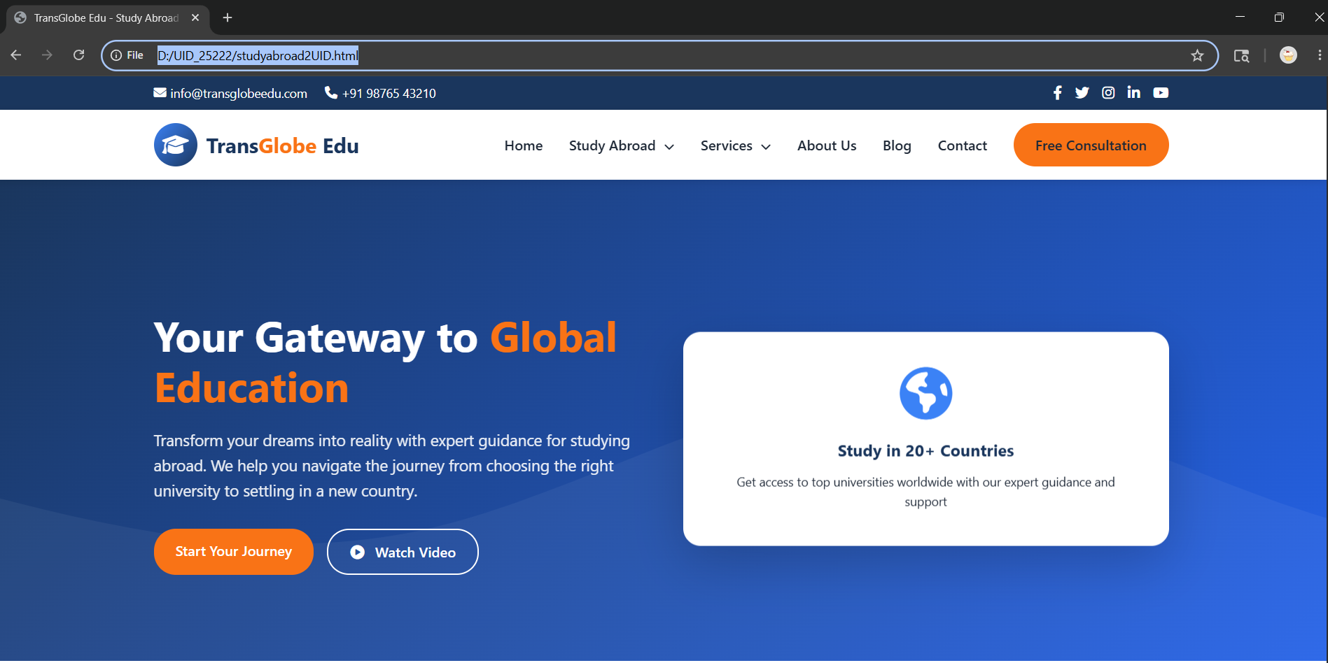
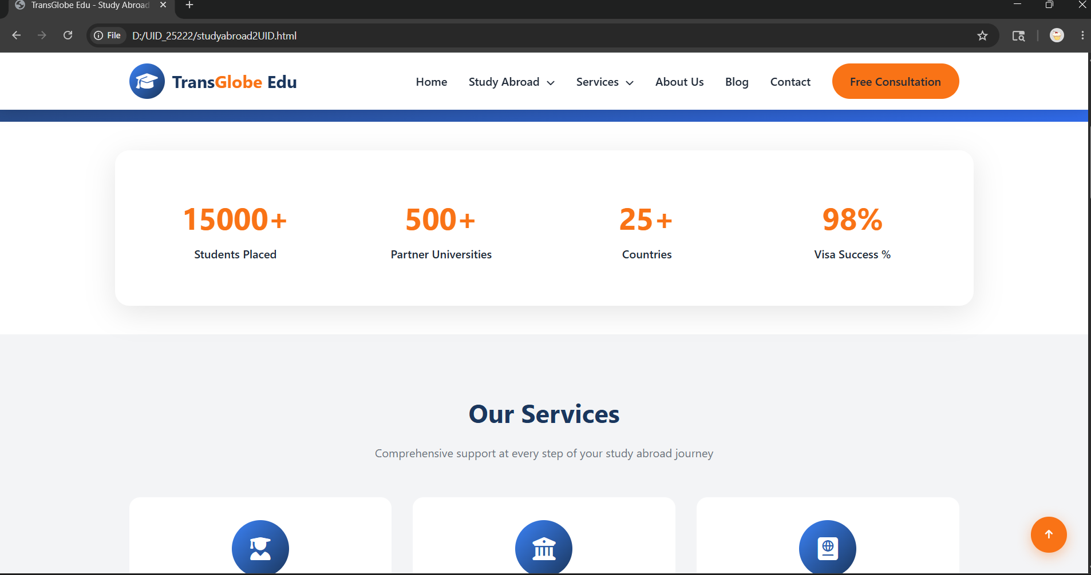
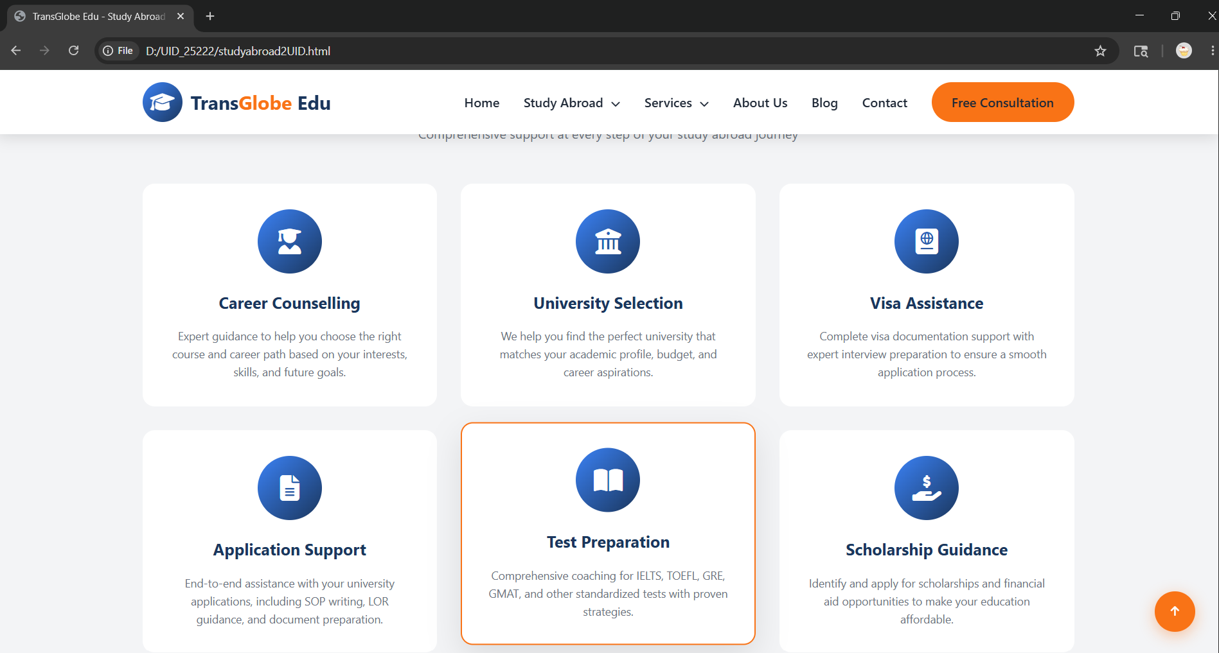
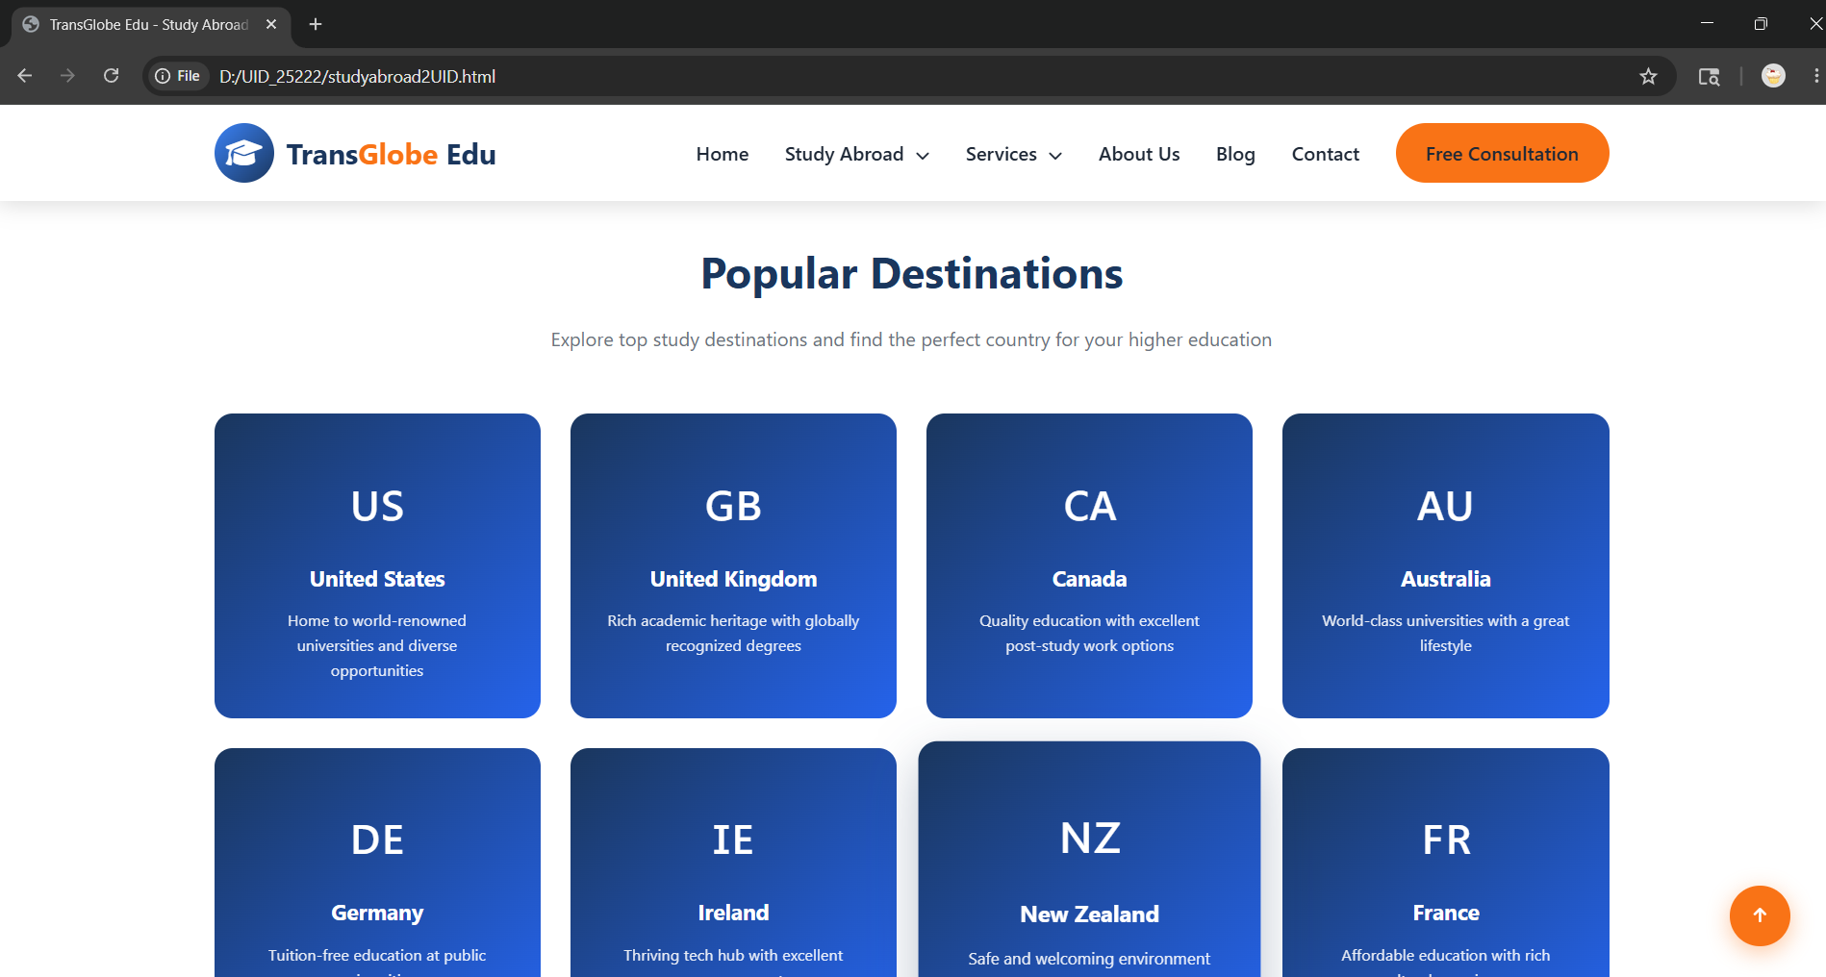
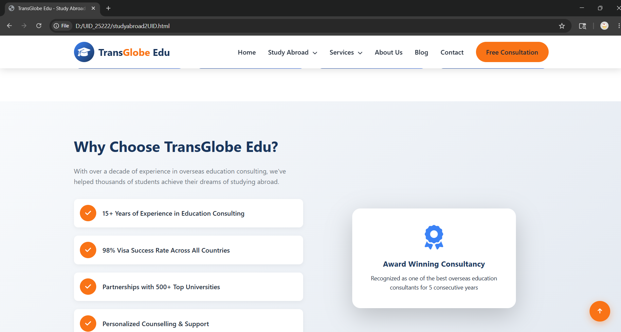
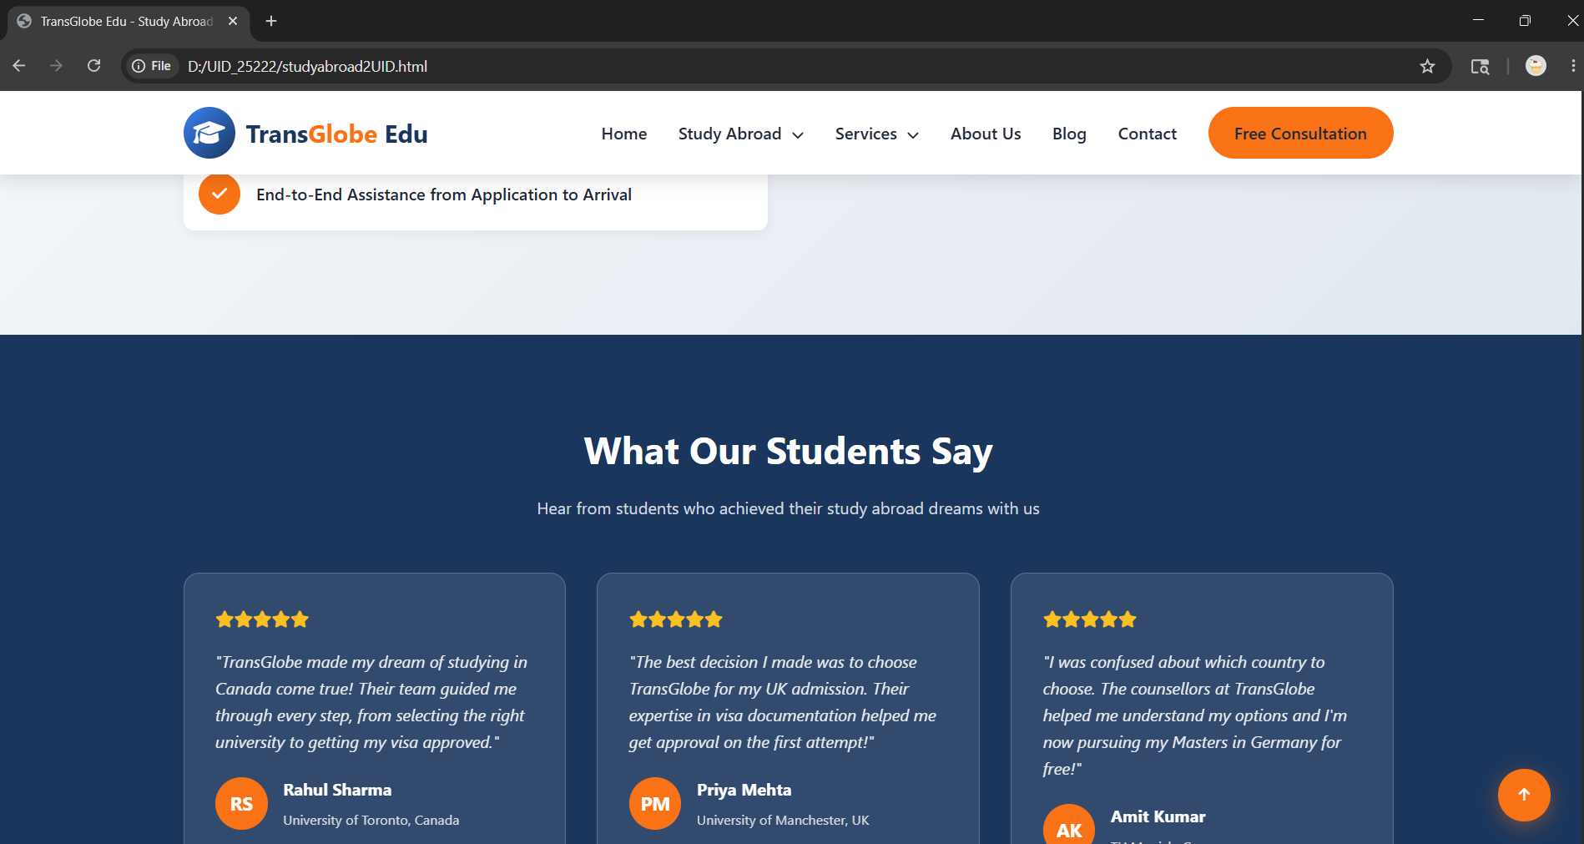
Explanation of tags –
<html> - | Root element that contains the entire web page.
<head> - | Stores metadata, title, fonts, and styling information.
<title> - | Sets the title displayed on the browser tab.
<style> - | Contains internal CSS used for designing the webpage.
<body> - | Holds all visible content displayed on the webpage.
<nav> - | Creates the navigation bar section of the website.
<div> - | A container element used to group and organize content.
<section> - | Defines different sections of the webpage such as About, Services, and Contact.
<a> - | Creates hyperlinks for navigation between sections.
<h1> - | Displays the main heading of the webpage.
<h2> - | Displays section headings.
<h4> - | Displays subheadings within cards and content areas.
<h5> - | Used for smaller headings such as testimonials and destination names.
<p> - | Displays paragraphs and descriptive text.
<img> - | Inserts images into the webpage.
<button> - | Creates clickable buttons for user interaction.
<form> - | Creates a form for collecting user information.
<input> - | Allows users to enter data such as name and email.
<textarea> - | Provides a larger text area for user messages.
<footer> - | Defines the footer section of the webpage.
<script> - | Contains JavaScript code used for webpage functionality.
<link> - | Connects external resources such as Google Fonts.

